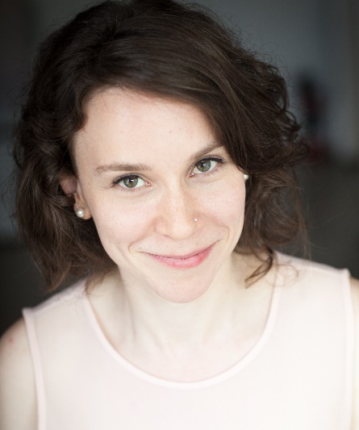
A native of Quebec City, coloratura mezzo-soprano Marie-André Mathieu is praised for her sumptuous and warm voice, and renowned for her remarkably accurate vocalises.

Named “jeune ambassadeur lyrique 2016,” she was also a semifinalist at the Concours OSM Standard Life 2014, won first prize in Quebec’s Concours d’art lyrique de la Relève musicale, and first place at the Concours solo avec orchestre of Laval University.

Her artistic profile makes her naturally fit for “pants roles.” She was Nicklausse in Offenbach’s Les contes d’Hoffmann at the Opéra-Théâtre de Rimouski. With her special affinity with the Baroque repertoire, she delivered a notable performance as Orphée in Gluck’s masterpiece for the Relève musicale de Québec, and as Junon in Charpentier’s Actéon, produced by the Compagnie Baroque Mont-Royal in Montreal. Her surprising vocal agility makes her perfect for Rossini, with roles such as Lucilla in La scala di seta, under the direction of Maestro Alberto Zedda, at the Lunenburg Academy of Music Performance in Nova Scotia.

She is regularly invited as a soloist for recitals, including for Duruflé’s Requiem at the Basilique-cathédrale Notre-Dame de Québec, under director Airat Ichmouratov, as well as in Haendel’s Dixit Dominus with the Choeur polyphonique de Charlevoix. In the last years, she sang for Tempêtes & Passions, Les poètes de l’Amérique française, Les Après-midis des Ursulines, Musique de chambre Sainte-Pétronille and Les Concerts Couperin among others.

Ms. Mathieu holds a Master’s degree in classical singing performance from Laval University, where she graduated with an award for excellence. Ms. Mathieu completed a Bachelor’s degree in classical singing performance, where she won the Patricia-Poitras scholarship for best results at the final recital. She studied with soprano Patricia Fournier, with whom she still works to this day.

A very versatile musician, Marie-Andrée Mathieu has also studied piano and guitar. Since her stage debut, Ms. Mathieu has performed in a wide range of styles, including Brazilian music and French song. Among other projects, she is the lead singer in French song ensemble La Virevolte. She is also a member of La Chapelle de Québec, the official chamber choir for world renowned orchestra Les Violons du Roy.

In the coming months, she will be Sister Osmina in Puccini’s Suor Angelica for the Opéra de Québec.

